OS LAB 1
FCFS NON PREEMPTIVE SCHEDULING
#include <stdio.h>
int main()
{
int n, i;
printf("Enter number of processes: ");
scanf("%d", &n);
int bt[n], wt[n], tat[n];
float avg_wt = 0, avg_tat = 0;
for(i = 0; i < n; i++)
{
printf("Enter Burst Time for Process %d: ", i + 1);
scanf("%d", &bt[i]);
}
wt[0] = 0;
for(i = 1; i < n; i++)
{
wt[i] = wt[i - 1] + bt[i - 1];
}
for(i = 0; i < n; i++)
{
tat[i] = wt[i] + bt[i];
avg_wt += wt[i];
avg_tat += tat[i];
}
printf("\nProcess\tBurst Time\tWaiting Time\tTurnaround Time\n");
for(i = 0; i < n; i++)
{
printf("P%d\t%d\t\t%d\t\t%d\n", i + 1, bt[i], wt[i], tat[i]);
}
printf("\nAverage Waiting Time = %.2f", avg_wt / n);
printf("\nAverage Turnaround Time = %.2f\n", avg_tat / n);
return 0;
}
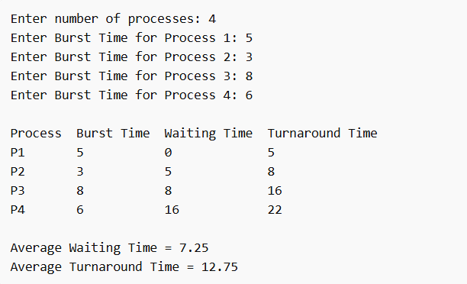

FCFS PREEMPTIVE SCHEDULING

#include <stdio.h>
struct Process {
int pid;
int arrival;
int burst;
int waiting;
int turnaround;
int completed;
};
int main() {
int n;
printf("Enter number of processes: ");
scanf("%d", &n);
struct Process p[n];
for(int i = 0; i < n; i++) {
printf("\nProcess %d\n", i+1);
p[i].pid = i+1;
printf("Arrival Time: ");
scanf("%d", &p[i].arrival);
printf("Burst Time: ");
scanf("%d", &p[i].burst);
}
fcfs(p, n);
return 0;
}
void fcfs(struct Process p[], int n) {
int time = 0;
float total_wt = 0, total_tat = 0;
for(int i = 0; i < n-1; i++) {
for(int j = 0; j < n-i-1; j++) {
if(p[j].arrival > p[j+1].arrival) {
struct Process temp = p[j];
p[j] = p[j+1];
p[j+1] = temp;
}
}
}
for(int i = 0; i < n; i++) {
if(time < p[i].arrival)
time = p[i].arrival;
p[i].waiting = time - p[i].arrival;
p[i].turnaround = p[i].waiting + p[i].burst;
time += p[i].burst;
total_wt += p[i].waiting;
total_tat += p[i].turnaround;
}
printf(" FCFS Scheduling \n ");
printf("Average Waiting Time: %.2f\n", total_wt/n);
printf("Average Turnaround Time: %.2f\n", total_tat/n);
}

